Final Project: Pick a Project
Computer Science - Week 10
Oct 3, 2026 - Version 0.0.2
Please make sure to your UD email AND name is below. Unless your UD emails are included in this table, then you will not earn any points for this assignment when it is graded! Every person should submit their own individual worksheet.

Talk about each of the questions with a friend or our LLM (or both), but make sure the words you enter below are yours (with the obvious exceptions notwithstanding). Brainstorming is best done in full sentences, and the main goal here is brainstorming. It's worth reviewing the information in this series of pages in the Drafter documentation to gain a better understanding of the process.

Role | Name | Email
Developer (You) | Kate Riker | rikerk@udel.edu
Friend (optional) | Souritra Bhattacharjee | souritra@udel.edu

Part 1: The Goal & Prior Implementations
- Identify the Goal: What specific goal are you trying to address? Think about your passions, hobbies, and academic interests. The latter are an excellent candidate to focus on. Some majors have suggestions listed below: these were provided by faculty in those departments. Other majors could consider a focus tied to a big final assignment in one of their recent courses in their major.
  - Majors in the Electric & Computer Engineering department may consider a steganography project that hides messages in images, and then retrieves those messages.
  - Biomedical Engineering majors may consider one of the following:
    - If you have started (or completed) the Cell/Tissue Design final project in BMEG100, design an organoid, which involves combining a cell type, biomaterial, and testing method. Have the website include a description and diagram of your design concept, a testing method, a needs statement, and an impact statement relevant to their organoid. Also include a link to a paper that supports your idea and a paragraph describing how that paper supports your design concept.
    - Otherwise, create a website related to your BMEG100 Lab Report 1, Cytoskeletal and Nuclear Staining Lab Report Guidelines, linked here (University of Delaware account required to access).
  - Chemistry and Chemical Engineering majors may consider the project below.
    - Create an automated chemistry assistant that takes balanced reaction equations, starting reactant masses, and a harvested product amount to determine the limiting reactant, theoretical yield, and percent yield based on principles from Chemistry 2e (OpenStax) — Chapter 4: Chemical Reactions and Stoichiometry. To avoid manually compiling atomic mass tables or writing custom string tokenizers, use the chempy library to parse molecular formulas into exact molecular weights and verify reaction stoichiometry against compound data from the NIH PubChem Database. The program outputs an organized breakdown of limiting reagent status, product yields, and remaining masses of unreacted species. Also use the heat of the reaction to determine if it is exothermic or endothermic, and compute the heat flow per mole of the product.
The goal my project is trying to address is finding a way to help students who struggle picking which assignment to do first and how to prioritize certain assignments to get the best grade possible.

- Prior Implementations: Search the internet. What existing tools or websites currently attempt to address it?
There are many different apps and websites that attempt to help students track their grades and assignments. For example: Notion, GradePoint, and Mystudylife.

- Your Implementation: Briefly describe the legitimate purpose or functionality of your site. How would you want this web application to be used?
The student would input information about their assignments, grades, priorities, upcoming tests, etc. and the website would use this information to rank the priority of projects, show how to balance workload, and help calculate grades.

Part 2: The Input-Process-Output (IPO) Model
Think about the fundamental flow of your program.
- The Core Goal: Every program has three main phases: taking input, processing data, and presenting output. In one sentence, what is the ultimate goal your program will accomplish for the user? Be specific and use CS1 concepts.
The ultimate goal the program will accomplish is taking in the students information as an input. Then processing their information and outputting information that can be useful to the user when planning their school work schedule.

- Input: What specific information will the user need to provide to your program? (e.g., a city name, a numerical budget, a list of hobbies).
List of classes and grades, priorities of assignments, weight of assignments

- Processing: At a high level, how will the computer manipulate or evaluate that data? (e.g., calculate the average, filter out options that are too expensive, compare the input against a database).
It will compare the weight and priorities of the assignments and the users grade in the class to evaluate what should be done first.

- Output: What will the user get back? (e.g., a recommendation, a calculated safety factor, a formatted schedule).
The user will get a ranked list of assignments from highest to lowest priority and recommendations for assignments to work on first.

Part 3: Data Abstraction
Identify the "nouns" of your problem.
- Representing Reality: Abstraction is the process of representing the real world inside a computer by ignoring unnecessary details. What are the core "things" (nouns) your program needs to track? (e.g., If building a recipe app, the nouns are "Recipe" and "Ingredient").
The core things my program needs to track are the student, courses, assignments, and grades.

- Identifying Properties: For the most important "thing" you listed above, what 3 to 4 specific details do you actually need to solve your problem, and what details will you abstract away?
  - Details I need: (e.g., Ingredient name, weight, cost)
  - Details I will ignore: (e.g., Ingredient color, brand, expiration date)
For the assignments I will need the course name, due dates, and if it is done or not. I will also need how difficult it is and the estimated time to complete. I can ignore the teachers name, class time, and class location.

Part 4: Challenges, AI Strategy, & Goals
- Difficulties: What parts of this project seem the most difficult or technically complex?
Making sure my code fulfills all the requirements and determining the routes and pages.

- Coding Strategy: If you will be using an LLM to help code, how will you ensure you understand the generated code and avoid "hallucinations" or "shallow learning" (copying without understanding)? If you won't be using an LLM to help code, this project might take about 4 hours a week to complete, so list each of the days and times in which you work on the project.
I will make sure the code has no functions or concepts that I don't understand how to use myself. If there is something I do not understand because we have not learned how to do it that specific way I will learn how the code runs and sections I don't understand.

- Goals: What is your ultimate goal for this project? (e.g., Impress the graders with a creative UI, build something I can use in my other classes, learn Drafter deeply).
My ultimate goal for this project is to create something that I would genuinely be able to use to improve the way I manage my time and study.

Part 5: Research & Brainstorming Conversation
Have a conversation with a Generative AI tool (like ChatGPT or Claude) OR a friend about your project idea. Do not ask for code. Instead, use the AI/friend as a sounding board to research your problem.
- The Initial Prompt/Question: Ask the AI or your friend to help you brainstorm. (e.g., "I want to build a simple web tool to help students track their study hours. What are 3 common problems students face when tracking their time, and what are 3 simple features a basic tool should have?"). Paste your prompt below:
I asked my friend to help me brainstorm which features would be most helpful for a student who wants to figure out which assignments should be prioritized and how to do best in the class.

- The Response: Briefly summarize the best ideas the AI or your friend suggested. What existing solutions or prior apps did they mention?
My friend suggested that I give a suggested calendar to the user so they know which days to do what assignments. They mentioned there was google calendar and google tasks that can track assignments but neither rank by importance of assignments.

- The Pushback: You must reply to the AI/friend to narrow the scope when it's over-ambitious. Pick the most complex feature they suggested and explain why it is too complicated for an introductory programming project. Ask them for a simpler alternative. Paste your response here:
The potentially most complicated feature was making a personalized study schedule based on every assignment. This could be difficult because it takes into account many different variables. Instead I could create a priority ranking that uses the assignment due dates, difficulty and estimated completion time to figure out which assignments students should work on first.

- Reflection: Based on this conversation, how has your project idea changed or become more focused?
This conversation helped me reconsider what outputs would be most practical and how the program will help the user.

Part 6: Resource Planning
- What resources will you use if you get stuck?
If I get stuck I will use LLM or go to office ours to talk to the TA’s

- If your LLM provides code that causes a Drafter or Bakery error, or if you run into a problem during deployment, what is your step-by-step debugging plan to resolve it?
If I get an error I will read the error message and try to understand what went wrong. Then I will find the part of the code that is causing the error and check for spelling mistakes, wrong variables, or syntax errors. I can also test the code in different smaller sections to figure out where the issue is. If I cannot figure it out then I will go to a TA for help.

Part 7: LLM Conversation
If you used an LLM in any part of this work, copy and paste every part of that conversation below. Otherwise, you may be given a zero for the assignment. Obviously, these words will not all be yours, and this is the exception to the requirement at the top of this assignment that all responses be in your own words. If you did not use an LLM to assist you in this assignment, simply say so below.
“give me ideas for websites that incorporate math with a tracker for student's assignments, grades, priorities to help them succeed that can be made with complex code and follows the project requirements”
Based on your CS1 Final Project Alpha worksheet, I would recommend building a student success dashboard that combines assignment tracking, grade calculations, prioritization, and mathematical analysis. Your project needs to be more than a website that stores information: it should take user input, process that information using Python, and produce useful results. It also needs clear data abstraction, a realistic scope for a three-week introductory programming project, and a plan for handling technical challenges.
Since you're using Drafter, you can make the site feel advanced with interactive components, graphs, calculations, filters, and saved data without needing to build a backend or database.

5 website ideas that combine math and student productivity
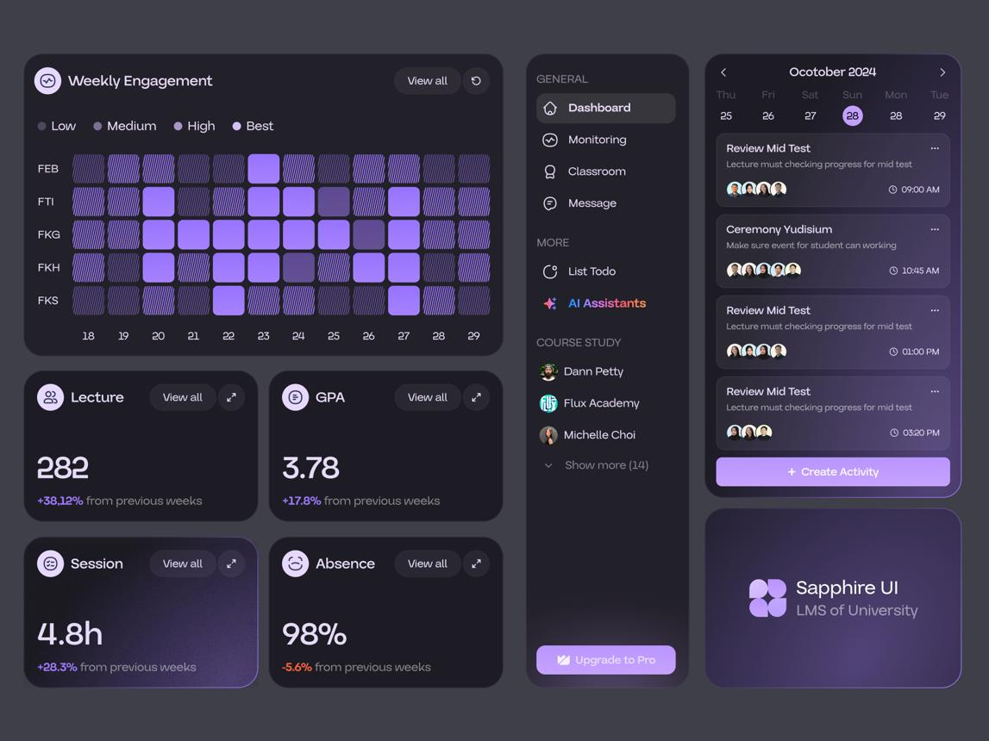

1. GradePilot — Student Success Dashboard
Best overall choice
A personal academic command center that tracks assignments, grades, deadlines, and priorities in one place.
Math involved
- Calculate current grade averages.
- Calculate weighted course grades.
- Determine what scores are needed on future exams to reach a target grade.
- Calculate assignment priority scores using urgency, difficulty, and importance.
Advanced features
- Grade trend graphs using Matplotlib.
- An assignment dashboard with overdue, upcoming, and completed filters.
- A "What should I work on next?" recommendation.
- Progress bars toward semester goals.
Difficulty: Medium–high, with a realistic core version for CS1.
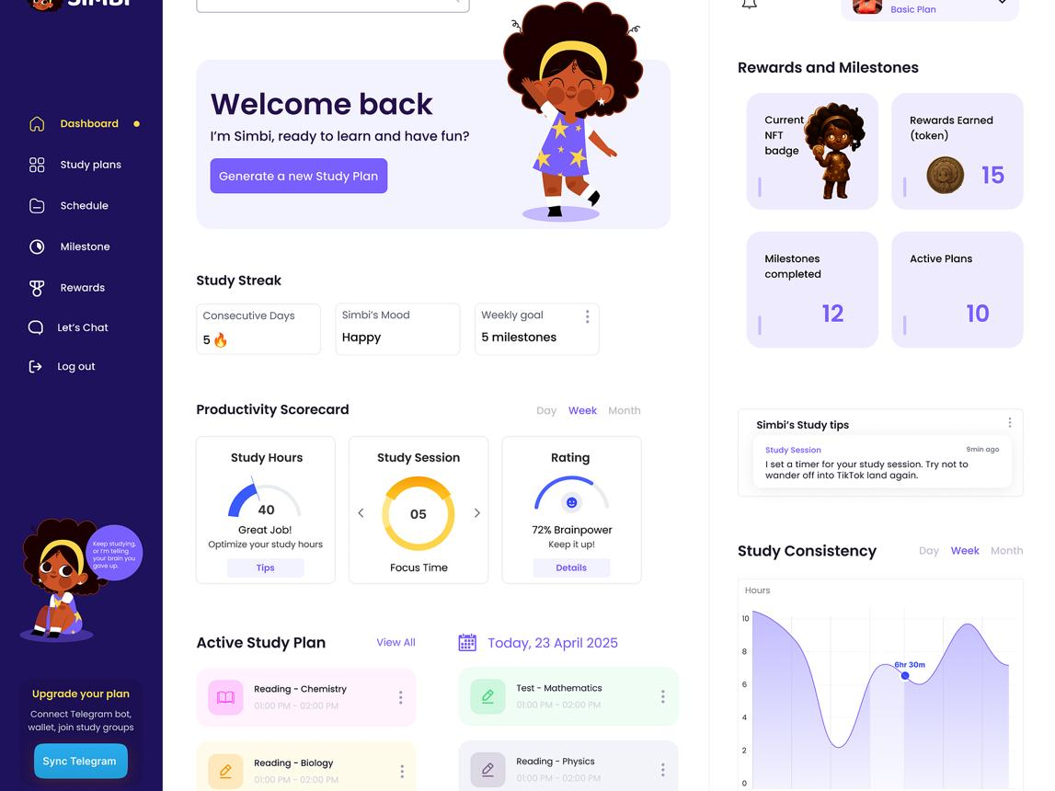

2. StudySmart — Smart Assignment Prioritizer
A planner that calculates which assignments deserve attention first instead of sorting everything only by due date.
Math involved
- Days or hours remaining until deadlines.
- A weighted priority formula.
- Estimated workload per day.
- Total workload compared with available study hours.
Advanced features
- Adjustable sliders for importance and difficulty.
- Color-coded urgency levels.
- A daily workload graph.
- A suggested study schedule based on available time.
Difficulty: Medium. The simplest idea to finish reliably.
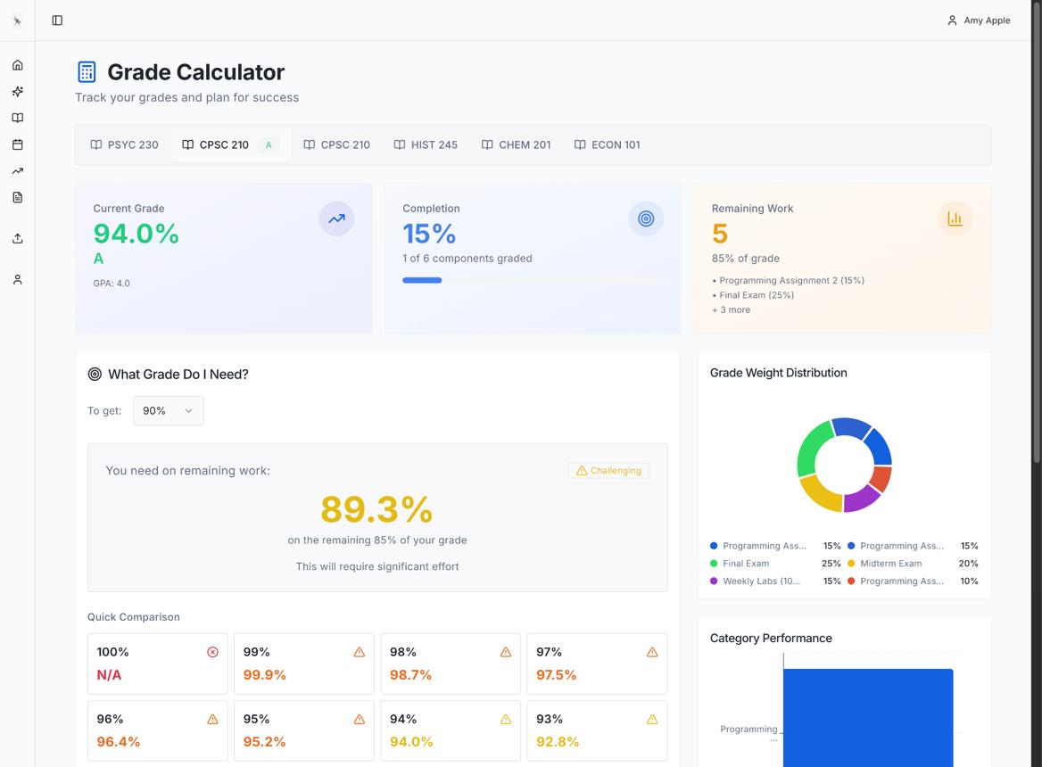

3. GradeQuest — Grade Goal Simulator
A grade tracker that helps students understand how their next exam, quiz, or project could affect their final grade.
Math involved
- Weighted averages and percentage calculations.
- GPA estimation using a grading scale selected by the user.
- Required-score calculations.
- Best-case and worst-case grade projections.
Advanced features
- A target-grade slider.
- A "What if I get 75%, 85%, or 95%?" comparison.
- Course-by-course grade charts.
- Alerts when a target is mathematically unattainable under the entered assumptions.
Difficulty: Medium. Best if you enjoy equations and numerical problem-solving.
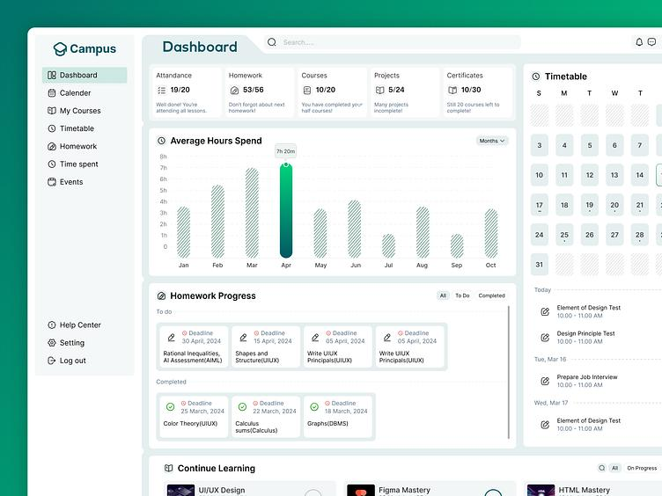

4. TimeWise — Study Time and Workload Analyzer
Helps students plan their time by comparing upcoming academic work with the hours they have available.
Math involved
- Total estimated work hours.
- Available versus required study time.
- Average completion time.
- Workload distribution across a week.
Advanced features
- A study session timer.
- Actual-versus-estimated study time charts.
- A weekly workload heatmap.
- A warning when planned study hours exceed available hours.
Difficulty: Medium. Great for timers, data visualization, and time calculations.
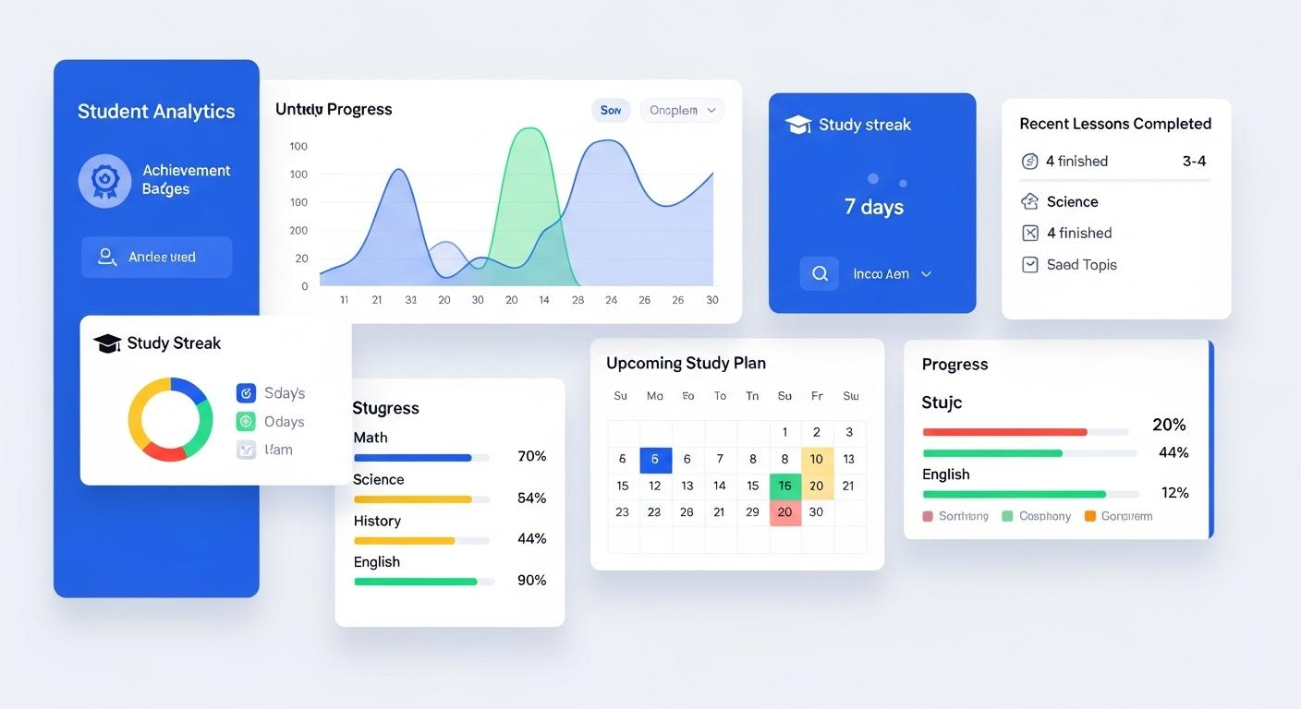

5. ScholarStats — Academic Progress and Motivation Tracker
Turns academic work into measurable progress, using statistics and a reward system to encourage consistent habits.
Math involved
- Assignment completion percentages.
- On-time submission rates.
- Weekly study-hour averages.
- Points, streaks, and progress toward goals.
Advanced features
- Achievement badges and levels.
- Weekly performance comparisons.
- Completion trend graphs.
- Personal goals such as completing 90% of assignments on time.
Difficulty: Medium. Best for a visually polished, engaging website.

My recommendation: combine ideas 1, 2, and 3
Build GradePilot: an intelligent student planner and grade analyzer. This gives you a project with enough mathematical processing and code complexity to stand out, while still being achievable in three weeks.

What the finished website could include

GradePilot
Your academic command center
Current average

87.4%
Target: 90%
Pending tasks

6
2 high priority
Weekly completion
70%
7 of 10 assignments completed

Today's recommended task
Calculus problem set
Due tomorrow · Difficulty 5/5 · Estimated 2 hours
Urgent

Grade goal simulator
What score do you need on your next exam?
Current grade

87%
0%
100%
Next exam weight

25%
5%
60%
Desired grade

90%
50%
100%
Required exam score

99%
This assumes your current grade represents all other work and the exam makes up 25% of the final grade.
Illustrative interactive mockup, not live student data.

The math that makes your project impressive
These calculations turn the site from a simple checklist into a useful decision-making tool.

1. Assignment priority algorithm
Give each assignment a due date, difficulty rating, importance rating, and estimated completion time.
For example, define a priority score:
P=4U+3D+3I
P=4U+3D+3I
Where:
- U
- U = urgency from 1 to 5
- D
- D = difficulty from 1 to 5
- I
- I = importance from 1 to 5
An assignment due tomorrow might have urgency 5, difficulty 4, and importance 5.
P=4(5)+3(4)+3(5)=47
P=4(5)+3(4)+3(5)=47
Your Python program calculates the score for every pending assignment, sorts them from highest to lowest, and recommends what to work on first. The weights are your chosen design, not a scientifically validated formula.

2. Grade and GPA calculator
- Calculate the average of quiz and exam grades.
- Account for different category weights.
- Estimate GPA using a user-selected grading scale.
- Calculate the score needed to reach a target grade.
- Compare possible exam outcomes.
One important detail: distinguish a simple average from a weighted average. If exams count for 50% and homework counts for 20%, you need the full grading scheme to calculate an accurate course grade.

3. Workload balancing
Calculate how many study hours are needed across all assignments and compare them with the student's available hours.
For example, if a student has 12 hours of work but only 8 hours available, the program can identify a four-hour shortfall and suggest prioritizing the most urgent assignments.

4. Visual analytics
Use Matplotlib to generate:
- A bar chart comparing grades across courses.
- A pie chart showing assignment completion.
- A line graph tracking grade changes over time.
- A workload chart comparing estimated and actual study hours.
Drafter supports Matplotlib through Pyodide, so charts are a realistic option, although loading additional packages can increase initial page-load time.
Drafter Documentation
+1

How to satisfy each part of your project worksheet
Your uploaded worksheet asks you to address the problem, existing solutions, IPO model, data abstraction, technical challenges, AI strategy, brainstorming, and resource planning.
CS1 Final Project Alpha F26.pdf
Worksheet section | How GradePilot addresses it
Problem | Students struggle to organize assignments, estimate grades, and decide what to do first.
Prior solutions | Research tools such as MyStudyLife for academic planning, Google Calendar for deadlines, and Gradescope for grading workflows. Explain what your solution combines or does differently.
Your solution | A personal dashboard that tracks tasks, analyzes grades, and recommends priorities.
Input | Assignment names, due dates, difficulty, estimated hours, course grades, category weights, and goals.
Processing | Calculate averages, required scores, urgency, priority scores, and workload totals.
Output | Sorted assignments, grade predictions, charts, progress indicators, and study recommendations.
Data abstraction | Model each assignment with only the information necessary for tracking and calculations.
Challenges | Managing lists of objects, sorting tasks, validating inputs, handling grade formulas, drawing charts, and saving data.
AI strategy | Ask AI to explain one function at a time, test it with sample data, and explain the logic back in your own words.
Resource planning | Use the course materials, Drafter documentation, small test cases, and instructor or TA help.
The named products above are research starting points for your worksheet, not claims that they offer exactly the same feature set.

Recommended data model
Keep your data structures understandable while allowing for more sophisticated processing.
Assignment
Name · Course · Due date · Difficulty · Estimated hours · Points possible · Points earned · Completed
Course
Course name · Grading categories · Category weights · Target grade
StudySession
Assignment · Date · Planned minutes · Actual minutes
In Drafter, these could be represented using Python dataclasses and lists, with routes that update the application's state. You can save student data in browser local storage, but the application won't automatically have a shared database or user accounts. Drafter's browser execution model and its limitations are described in the
official documentation
.
GitHub
+1

How to make the code complex without making the project unrealistic
Core requirements
Add, edit, complete, and delete assignments; sort by priority; calculate grade averages; show a dashboard; save and reload data.
Advanced features
Weighted grades, target-grade simulation, Matplotlib graphs, date-based urgency, search and filtering, study-time analytics.
Optional stretch goal
Generate a suggested weekly study schedule from assignment deadlines and available hours. Keep this as a simple rule-based algorithm, not an AI scheduling service.
I would avoid building login systems, teacher portals, real-time collaboration, cloud synchronization, or an external AI tutor. Those introduce backend or integration challenges that aren't necessary to demonstrate strong CS1 programming.

A realistic three-week development plan
- Week 1 — Build the foundation
- Create the Drafter routes and dashboard. Add assignment forms, an assignment data model, task completion, and basic grade calculations.
- Week 2 — Implement the math
- Add priority scoring, sorting, weighted grade calculations, target-grade simulation, input validation, and local data persistence.
- Week 3 — Add analytics and polish
- Add charts, progress indicators, filters, responsive layouts, test cases, and error handling. Reserve the final days for debugging and preparing your project explanation.
My final recommendation: Choose GradePilot, with assignment prioritization as its main differentiator and grade simulation as its strongest mathematical feature. That combination gives you meaningful Python logic, visible results, and an impressive interface while keeping the core project achievable.

Part 8: Submit
In Google docs, with this document open, please click on File > Download > Microsoft Word (.docx), and make sure you put that download somewhere you can find it again. Then, upload it to the Canvas assignment about selecting or brainstorming your final project.

When you're done with this assignment, review this page of the Drafter documentation to better prepare for the next step.

